Purchase Order
 | Food Allergy Education Products | Date [Enter a date]  Invoice # [100]  Terms Net 30

Kyle Dine  158 Bradstone St.  Kingston, ON, K7P 3J2  Canada  Phone 781-361-9932  Fax 815-301-1793  kyledine@gmail.com | TO | [Name]  [Company Name]  [Street Address]  [City, ST ZIP Code]  Phone [000-000-0000]  Customer ID [ABC123]

Item # | Qty | Description | Unit Price | Line Total
 |  |  | Subtotal
 |  |  | Shipping
 |  |  | Total

Shipping Cost Chart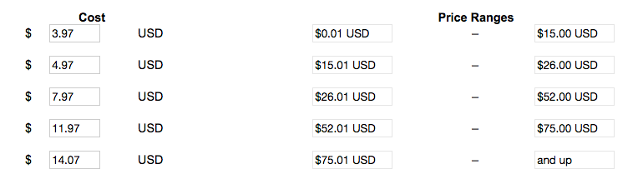

Thank you for your business!

